WEEK – 1 – Design Patterns and Principles

Exercise 1: Implementing the Singleton Pattern
Logger.java:
public class Logger {
private static Logger instance
private Logger() {
System.out.println("Logger instance created");
}
public static Logger getInstance() {
if (instance == null) {
instance = new Logger();
}
return instance;
}
public void log(String message) {
System.out.println("LOG: " + message);
}
}

SingletonTest.java:
public class SingletonTest {
public static void main(String[] args) {
Logger logger1 = Logger.getInstance();
Logger logger2 = Logger.getInstance();
logger1.log("First message");
logger2.log("Second message");
if (logger1 == logger2) {
System.out.println("Only one Logger instance exists.");
} else {
System.out.println("Multiple Logger instances exist.");
}
}
}

Terminal Output:
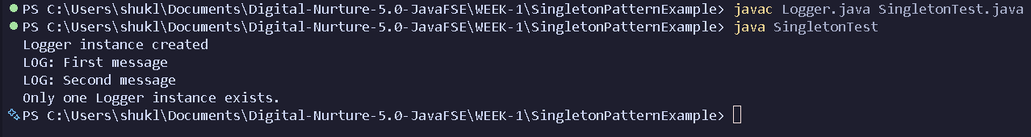

Exercise 2: Implementing the Factory Method Pattern
Document.java:
public interface Document {
void open();
}

WordDocument.java:
public class WordDocument implements Document {
@Override
public void open() {
System.out.println("Opening Word Document");
}
}

PdfDocument.java:
public class PdfDocument implements Document {
@Override
public void open() {
System.out.println("Opening PDF Document");
}
}

ExcelDocument.java:
public class ExcelDocument implements Document {
@Override
public void open() {
System.out.println("Opening Excel Document");
}
}
DocumentFactory.java:
public abstract class DocumentFactory {
public abstract Document createDocument();
}

WordDocumentFactory.java:
public class WordDocumentFactory extends DocumentFactory {
@Override
public Document createDocument() {
return new WordDocument();
}
}

PdfDocumentFactory.java:
public class PdfDocumentFactory extends DocumentFactory {
@Override
public Document createDocument() {
return new PdfDocument();
}
}

ExcelDocumenFactory.java:
public class ExcelDocumentFactory extends DocumentFactory {
@Override
public Document createDocument() {
return new ExcelDocument();
}
}

FactoryTest.java:
public class FactoryTest {
public static void main(String[] args) {
DocumentFactory wordFactory = new WordDocumentFactory();
Document wordDoc = wordFactory.createDocument();
wordDoc.open();
DocumentFactory pdfFactory = new PdfDocumentFactory();
Document pdfDoc = pdfFactory.createDocument();
pdfDoc.open();
DocumentFactory excelFactory = new ExcelDocumentFactory();
Document excelDoc = excelFactory.createDocument();
excelDoc.open();
}
}

Terminal Output:
